Introduction to Spring Boot
Spring Boot is an open-source Java framework built on top of Spring, designed to simplify the development of stand-alone, production-ready Spring applications with minimal configuration. It eliminates the need for extensive XML configurations and boilerplate code, making it easier to create robust and scalable applications.

Key Features of Spring Boot
- Auto-configuration – Automatically configures Spring components based on classpath dependencies.
- Standalone Applications – No need for an external server; applications can run as JAR files with an embedded server (Tomcat, Jetty, Undertow).
- Production-Ready – Built-in monitoring, metrics, and health checks via Spring Boot Actuator.
- Microservices Support – Simplifies the creation of microservices with built-in tools for service discovery, API gateways, and distributed tracing.
- Embedded Servers – Supports embedded Tomcat, Jetty, and Undertow, eliminating the need for separate deployment.
- Opinionated Defaults – Provides sensible defaults, reducing the need for manual configuration.
- Spring Boot Starters – Predefined dependency configurations (spring-boot-starter-web, spring-boot-starter-data-jpa, etc.).
- Externalized Configuration – Supports application.properties or application.yml for environment-based configurations.
- Security – Seamless integration with Spring Security for authentication and authorization.
- Integration with Cloud and DevOps – Easily deployable on AWS, Azure, Kubernetes, and integrates well with CI/CD pipelines.

Why Use Spring Boot?
- Reduces Development Time – Eliminates complex XML configurations and boilerplate code.
- Simplifies Deployment – Provides built-in servers for easy execution.
- Microservices Ready – Optimized for developing cloud-native and microservice-based architectures.
- Scalable & Maintainable – Built with enterprise-level applications in mind.
- Rich Ecosystem – Easily integrates with databases, message brokers, security frameworks, and DevOps tools.

Difference Between Spring and Spring Boot
Feature | Spring Framework | Spring Boot
Definition | A comprehensive framework for building Java applications with dependency injection and modular architecture. | A pre-configured framework built on top of Spring to simplify development with auto-configuration and embedded servers.
Configuration | Requires manual configurations (XML, Java-based). | Uses auto-configuration, reducing manual setup.
Dependency Management | Developers need to add multiple dependencies manually. | Provides starter dependencies (e.g., spring-boot-starter-web) to simplify dependency management.
Application Server | Requires external server deployment (Tomcat, Jetty, WildFly). | Comes with embedded servers (Tomcat, Jetty, Undertow) for standalone applications.
Microservices Support | Can be used for microservices but requires extra setup. | Designed for microservices architecture, integrates well with Spring Cloud.
REST API Development | Requires configuring DispatcherServlet, ViewResolvers, etc. manually. | Simplified with spring-boot-starter-web, eliminating extra configuration.
Spring Security | Requires explicit configuration for authentication and authorization. | Comes with default security (username: user, auto-generated password).
Logging | Developers need to configure logging manually (Log4j, SLF4J). | Uses Logback by default with pre-configured settings.
Testing | Requires setting up Spring context manually. | Provides built-in support for @SpringBootTest, MockMvc, and unit testing.
Monitoring & Actuator | No built-in monitoring tools. | Provides Spring Boot Actuator for health checks, metrics, and monitoring.
Profiles & Environment Config | Requires explicit setup for environment-specific configurations. | Supports externalized configuration via application.properties or application.yml.
Development Speed | Slower due to manual configuration. | Faster due to opinionated defaults and auto-configuration.
Live Reload & DevTools | Not available by default. | Includes Spring Boot DevTools for live reload and quick restarts.
Deployment | Requires WAR packaging and external server setup. | Supports JAR packaging with built-in servers, simplifying deployment.

Complete List of Spring Boot Annotations with Descriptions
- Core Annotations
  - @SpringBootApplication – Combines @Configuration, @EnableAutoConfiguration, and @ComponentScan.
  - @Configuration – Marks a class as a source of bean definitions.
  - @ComponentScan – Scans packages for Spring components.
  - @Bean – Declares a Spring-managed bean.
- Spring Boot Auto-Configuration
  - @EnableAutoConfiguration – Enables automatic configuration based on classpath dependencies.
  - @ConditionalOnClass – Configures a bean if a class exists in the classpath.
  - @ConditionalOnMissingBean – Registers a bean only if it's not already defined.
  - @ConditionalOnProperty – Configures beans based on application properties.
- Dependency Injection & Component Scanning
  - @Component – Marks a class as a Spring-managed component.
  - @Service – Specialized @Component for service-layer classes.
  - @Repository – Specialized @Component for DAO/repository classes.
  - @Autowired – Injects dependencies automatically.
  - @Qualifier – Specifies a specific bean to be injected when multiple exist.
- REST API & Web Annotations
  - @RestController – A combination of @Controller and @ResponseBody.
  - @Controller – Marks a class as an MVC controller.
  - @RequestMapping – Maps HTTP requests to handler methods.
  - @GetMapping, @PostMapping, @PutMapping, @DeleteMapping, @PatchMapping – Handle specific HTTP methods.
  - @RequestParam – Extracts query parameters from requests.
  - @PathVariable – Extracts values from the URI path.
  - @RequestBody – Maps request body to a Java object.
  - @ResponseBody – Converts return values to JSON/XML.
  - @CrossOrigin – Enables Cross-Origin Resource Sharing (CORS).
- Exception Handling
  - @ExceptionHandler – Handles exceptions within a controller.
  - @ControllerAdvice – Global exception handling for multiple controllers.
  - @ResponseStatus – Maps exceptions to HTTP status codes.
- Spring Boot Security
  - @EnableWebSecurity – Enables Spring Security.
  - @PreAuthorize – Restricts access to a method based on conditions.
  - @Secured – Defines security roles for methods.
  - @RolesAllowed – Specifies allowed roles.
- Data Persistence & JPA
  - @Entity – Marks a class as a JPA entity.
  - @Table – Specifies the database table name.
  - @Id – Marks a field as the primary key.
  - @GeneratedValue – Defines the primary key generation strategy.
  - @Column – Maps a field to a database column.
  - @Repository – Marks a DAO/repository class.
  - @EnableJpaRepositories – Enables JPA repositories.
  - @Transactional – Defines transaction boundaries.
- Caching
  - @EnableCaching – Enables caching support.
  - @Cacheable – Caches a method’s return value.
  - @CacheEvict – Removes entries from the cache.
  - @CachePut – Updates cached values.
- Spring Boot Testing
  - @SpringBootTest – Loads the full application context for testing.
  - @WebMvcTest – Loads only the web layer for testing.
  - @MockBean – Creates a mock implementation of a bean.
  - @DataJpaTest – Configures an in-memory database for JPA testing.
- Scheduling & Asynchronous Processing
- @EnableScheduling – Enables task scheduling.
- @Scheduled – Runs a method at a fixed interval.
- @EnableAsync – Enables asynchronous execution.
- @Async – Executes a method asynchronously.
- Spring Boot Actuator & Monitoring
- @EnableActuator – Enables Actuator for application monitoring.
- @Endpoint – Defines a custom Actuator endpoint.
- Profiles & Configuration Properties
- @Profile – Enables beans for specific profiles.
- @Value – Injects values from properties files.
- @ConfigurationProperties – Binds external configurations to Java objects.
- Spring Cloud & Microservices
- @EnableEurekaClient – Registers a service with Eureka.
- @EnableFeignClients – Enables Feign clients for inter-service communication.
- @HystrixCommand – Implements circuit breaker functionality.

What is Inversion of Control (IoC)?
Inversion of Control (IoC) is a principle where the control of object creation and dependency management is shifted from the program to the Spring Container. Instead of manually creating objects, Spring manages them. Implemented using IoC Container (ApplicationContext, BeanFactory). Spring Framework takes control over object creation and lifecycle.

What is Dependency Injection (DI)?
Dependency Injection (DI) is a design pattern in which the dependencies of a class are injected from the outside rather than being created inside the class. It helps in achieving loose coupling and improves testability. Achieved using Constructor Injection, Setter Injection, Field Injection. Spring Container injects dependencies.

Dependency Injection Types
- Constructor Injection (Recommended) ✅
  - Ensures mandatory dependencies are injected and makes objects immutable.
  - Improves testability and does not require @Autowired for single constructor cases.
  - Preferred for clean code, better encapsulation, and avoiding hidden dependencies.
- Setter Injection (Use for Optional Dependencies) ✅
  - Useful when dependencies are optional or need reconfiguration at runtime.
  - Allows modifying dependencies after object creation, which may lead to inconsistency.
  - Requires @Autowired on the setter method and is slightly more verbose.
- Field Injection (Not Recommended) ❌
  - Makes unit testing difficult as dependencies need reflection for mocking.
  - Introduces hidden dependencies that reduce maintainability and refactoring ease.
  - Violates encapsulation, allowing direct modification of dependencies.

Bean Scope
Bean Scope in Spring defines the lifespan and visibility of a bean, determining how many instances of a bean Spring creates and how long they live in the application context.

Types of Bean Scopes
1. Singleton (Default)
A single instance of the bean is created and shared across the entire Spring container. Suitable for stateless services like repositories and service classes.
2. Prototype
A new instance is created every time the bean is requested. Useful for stateful beans where each request needs a fresh object.
3. Request (Web Only)
A new instance is created for each HTTP request. Used for request-scoped data in web applications, such as tracking API requests.
4. Session (Web Only)
A single instance is created per HTTP session. Useful for storing user-specific data across multiple requests.
5. Application (Web Only)
A single instance is created for the entire application (ServletContext-wide). Used for global configurations or caching shared across users.

JPA (Java Persistence API)
- JPA is a Java specification that defines an API for object-relational mapping (ORM).
- It provides a standard way to manage relational data using Java objects instead of SQL.
- JPA is only an API; it requires an implementation like Hibernate or EclipseLink.

Hibernate
- Hibernate is a JPA implementation and the most popular ORM framework in Java.
- It provides features like automatic table mapping, lazy loading, caching, and transaction management.
- Hibernate extends JPA by offering additional functionalities beyond the standard API.
First Level Cache:
Each Hibernate Session has an in-memory cache. If an entity is fetched multiple times in a session, Hibernate retrieves it from the cache instead of querying the database. First query hits the database, but subsequent queries fetch data from the session cache.
Second Level Cache:
Caches entities across multiple sessions. Requires a third-party cache provider like EhCache, Redis, or Caffeine. It requires explicit configuration. Cache cleared when the SessionFactory is closed or manually evicted.

Example

Hibernate Configuration (hibernate.cfg.xml)
Create the Hibernate configuration file inside src/main/resources/hibernate.cfg.xml:
xml
CopyEdit
<!DOCTYPE hibernate-configuration PUBLIC
"-//Hibernate/Hibernate Configuration DTD 3.0//EN"
"http://hibernate.sourceforge.net/hibernate-configuration-3.0.dtd">

<hibernate-configuration>
<session-factory>
<property name="hibernate.connection.driver_class">org.sqlite.JDBC</property>
<property name="hibernate.connection.url">jdbc:sqlite:sample.db</property>
<property name="hibernate.dialect">org.hibernate.dialect.SQLiteDialect</property>
<property name="hibernate.hbm2ddl.auto">update</property>
<property name="hibernate.show_sql">true</property>
<property name="hibernate.format_sql">true</property>

<mapping class="com.example.User" />
</session-factory>
</hibernate-configuration>

Create Entity Class Without JPA (User.java)
package com.example;

import java.io.Serializable;

public class User implements Serializable {
private Long id;
private String name;
private String email;

public User() {}

public User(String name, String email) {
this.name = name;
this.email = email;
}

public Long getId() { return id; }
public void setId(Long id) { this.id = id; }

public String getName() { return name; }
public void setName(String name) { this.name = name; }

public String getEmail() { return email; }
public void setEmail(String email) { this.email = email; }
}

Create Hibernate Mapping File (User.hbm.xml)
Create src/main/resources/User.hbm.xml for Hibernate mappings:
xml
<!DOCTYPE hibernate-mapping PUBLIC "-//Hibernate/Hibernate Mapping DTD 3.0//EN"
"http://hibernate.sourceforge.net/hibernate-mapping-3.0.dtd">

<hibernate-mapping>
<class name="com.example.User" table="users">
<id name="id" column="id">
<generator class="identity"/>
</id>
<property name="name" column="name" type="string"/>
<property name="email" column="email" type="string" unique="true"/>
</class>
</hibernate-mapping>

Hibernate Utility Class (HibernateUtil.java)
package com.example;

import org.hibernate.SessionFactory;
import org.hibernate.cfg.Configuration;

public class HibernateUtil {
private static final SessionFactory sessionFactory = buildSessionFactory();

private static SessionFactory buildSessionFactory() {
try {
return new Configuration().configure().buildSessionFactory();
} catch (Throwable ex) {
throw new ExceptionInInitializerError(ex);
}
}

public static SessionFactory getSessionFactory() {
return sessionFactory;
}
}
🔹 This class loads Hibernate configuration and provides a SessionFactory.

Hibernate CRUD Operations (UserDAO.java)
package com.example;

import org.hibernate.Session;
import org.hibernate.Transaction;
import java.util.List;

public class UserDAO {

public void saveUser(User user) {
Transaction transaction = null;
try (Session session = HibernateUtil.getSessionFactory().openSession()) {
transaction = session.beginTransaction();
session.save(user);
transaction.commit();
} catch (Exception e) {
if (transaction != null) transaction.rollback();
e.printStackTrace();
}
}

public User getUser(Long id) {
try (Session session = HibernateUtil.getSessionFactory().openSession()) {
return session.get(User.class, id);
}
}

public List<User> getAllUsers() {
try (Session session = HibernateUtil.getSessionFactory().openSession()) {
return session.createQuery("FROM User", User.class).list();
}
}
}

7. Running the Application (Main.java)
package com.example;

public class Main {
public static void main(String[] args) {
UserDAO userDAO = new UserDAO();

// Create and save a user
User user = new User("John Doe", "john@example.com");
userDAO.saveUser(user);

// Retrieve and print the user
User retrievedUser = userDAO.getUser(1L);
System.out.println("User: " + retrievedUser.getName() + ", Email: " + retrievedUser.getEmail());

// List all users
userDAO.getAllUsers().forEach(u ->
System.out.println("User ID: " + u.getId() + ", Name: " + u.getName())
);
}
}

Spring Data JPA
- Spring Data JPA is a Spring Boot module that simplifies JPA and database interactions.
- It eliminates the need for boilerplate code by providing a high-level repository abstraction.
- Internally, it uses Hibernate as the default JPA provider.
- Provides an abstraction layer over JPA implementations like Hibernate.
- Integrated with Spring’s @Transactional

JPQL (Java Persistence Query Language)
JPQL is a query language in JPA used to query entities instead of database tables. It is similar to SQL but operates on entity objects and their attributes, not raw database tables and columns.
SELECT e FROM EntityName e WHERE e.attribute = :value
- Uses entity names instead of table names
- Uses attribute names instead of column names

Common JPQL Queries
Select All Records
@Query("SELECT s FROM Student s")
List<Student> findAllStudents();
Select with WHERE Clause
@Query("SELECT s FROM Student s WHERE s.name = :name")
Student findByName(@Param("name") String name);
Like Query
@Query("SELECT s FROM Student s WHERE s.name LIKE :pattern")
List<Student> searchByName(@Param("pattern") String pattern);
Ordering Results
@Query("SELECT s FROM Student s ORDER BY s.name ASC")
List<Student> findAllSorted();
Using JOIN
@Query("SELECT e FROM Employee e JOIN e.department d WHERE d.name = :deptName")
List<Employee> findByDepartment(@Param("deptName") String deptName);
Aggregation (COUNT, SUM, AVG, MAX, MIN)
@Query("SELECT COUNT(s) FROM Student s WHERE s.age > :age")
long countStudentsAboveAge(@Param("age") int age);
Delete Query
@Modifying
@Query("DELETE FROM Student s WHERE s.name = :name")
void deleteByName(@Param("name") String name);
Update Query
@Modifying
@Query("UPDATE Student s SET s.age = :age WHERE s.name = :name")
void updateAge(@Param("name") String name, @Param("age") int age);
Native Query
@Query(value = "SELECT * FROM users WHERE email = :email", nativeQuery = true) User findByEmail(@Param("email") String email);

@Modifying
The @Modifying annotation is used in Spring Data JPA when executing update or delete queries using JPQL or native SQL. It tells Spring that the query will modify database records.
How to use @Modifying
- Use it with @Query for UPDATE or DELETE statements
- Always use @Transactional when modifying data
- Return void, int, or long (number of affected rows)
@Repository
public interface StudentRepository extends JpaRepository<Student, Long> {
@Modifying
@Transactional
@Query("UPDATE Student s SET s.age = :age WHERE s.name = :name")
int updateAgeByName(@Param("name") String name, @Param("age") int age);
}

JPA Inheritance Strategies
JPA provides inheritance mapping strategies to store and manage hierarchical entity relationships in a relational database. Since databases do not have direct support for object-oriented inheritance, JPA maps class hierarchies into database tables using different strategies.
JPA provides four strategies to handle inheritance:

1. Single Table Strategy (SINGLE_TABLE)
- Stores all child entities in one table with a discriminator column to differentiate types.
- Fast retrieval but may have NULL values for unused fields in some entities.
import jakarta.persistence.*;

@Entity
@Inheritance(strategy = InheritanceType.SINGLE_TABLE)
@DiscriminatorColumn(name = "type", discriminatorType = DiscriminatorType.STRING)
public abstract class Vehicle {
@Id
@GeneratedValue(strategy = GenerationType.IDENTITY)
private Long id;

private String brand;
}

@Entity
@DiscriminatorValue("CAR")
public class Car extends Vehicle {
private int seats;
}

@Entity
@DiscriminatorValue("BIKE")
public class Bike extends Vehicle {
private boolean hasGear;
}

Generated Table:
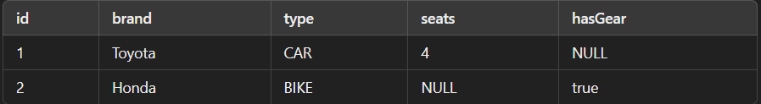

2. Joined Table Strategy (JOINED)
- Creates separate tables for each entity and joins them using primary keys.
- Normalized structure with no NULL values, but requires joins when querying.
import jakarta.persistence.*;

@Entity
@Inheritance(strategy = InheritanceType.JOINED)
public abstract class Vehicle {
@Id
@GeneratedValue(strategy = GenerationType.IDENTITY)
private Long id;

private String brand;
}

@Entity
@PrimaryKeyJoinColumn(name = "vehicle_id")
public class Car extends Vehicle {
private int seats;
}

@Entity
@PrimaryKeyJoinColumn(name = "vehicle_id")
public class Bike extends Vehicle {
private boolean hasGear;
}
Generated Tables:
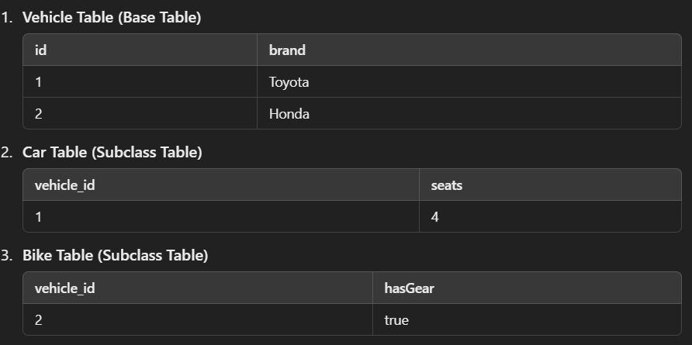

3. Table per Class Strategy (TABLE_PER_CLASS)
- Each class has its own table with no shared parent table.
- Each subclass has all fields from the base class, leading to data duplication.
- No joins required but redundant columns may exist in child tables.
import jakarta.persistence.*;

@Entity
@Inheritance(strategy = InheritanceType.TABLE_PER_CLASS)
public abstract class Vehicle {
@Id
@GeneratedValue(strategy = GenerationType.AUTO)
private Long id;

private String brand;
}

@Entity
public class Car extends Vehicle {
private int seats;
}

@Entity
public class Bike extends Vehicle {
private boolean hasGear;
}
Generated Tables:

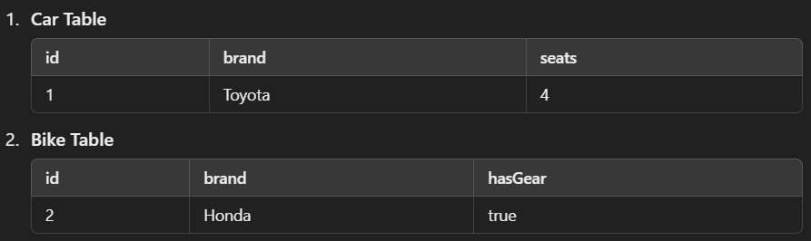

JPA Relationships

1. One-to-One (@OneToOne)
- One entity is related to exactly one other entity.
- Uses a foreign key in one table referring to the other entity's primary key.
- Commonly used for profile-user, passport-person relationships.
import jakarta.persistence.*;

@Entity
public class Person {
@Id
@GeneratedValue(strategy = GenerationType.IDENTITY)
private Long id;

private String name;

@OneToOne(cascade = CascadeType.ALL)
@JoinColumn(name = "passport_id", referencedColumnName = "id")
private Passport passport;
}

@Entity
public class Passport {
@Id
@GeneratedValue(strategy = GenerationType.IDENTITY)
private Long id;

private String number;

@OneToOne(mappedBy = "passport")
private Person person;
}
Generated Tables:

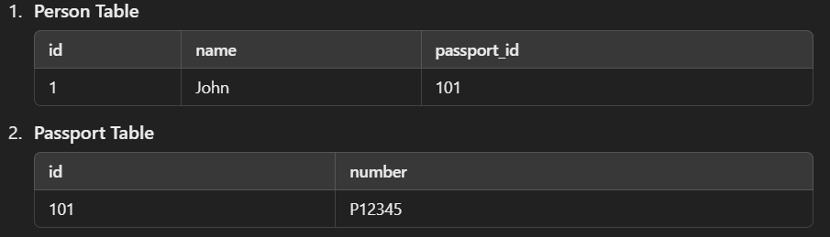

2. One-to-Many (@OneToMany)
- One entity is related to multiple instances of another entity.
- The child table stores a foreign key pointing to the parent table.
- Used for customer-orders, department-employees relationships.
import jakarta.persistence.*;
import java.util.List;

@Entity
public class Department {
@Id
@GeneratedValue(strategy = GenerationType.IDENTITY)
private Long id;

private String name;

@OneToMany(mappedBy = "department", cascade = CascadeType.ALL, orphanRemoval = true)
private List<Employee> employees;
}

@Entity
public class Employee {
@Id
@GeneratedValue(strategy = GenerationType.IDENTITY)
private Long id;

private String name;

@ManyToOne
@JoinColumn(name = "department_id") // Foreign key column in Employee table
private Department department;
}

Generated Tables:
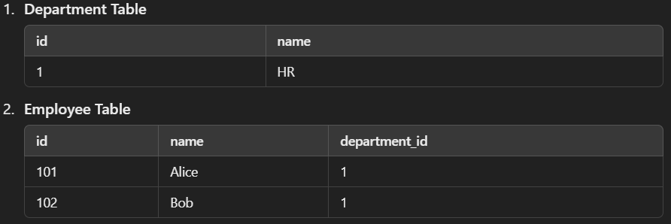

3. Many-to-One (@ManyToOne)
- Multiple entities are related to one instance of another entity.
- The foreign key is stored in the child table pointing to the parent.
- Used for employees belonging to a single department.
import jakarta.persistence.*;

@Entity
public class Employee {
@Id
@GeneratedValue(strategy = GenerationType.IDENTITY)
private Long id;

private String name;

@ManyToOne
@JoinColumn(name = "department_id") // Foreign key in Employee table
private Department department;
}

@Entity
public class Department {
@Id
@GeneratedValue(strategy = GenerationType.IDENTITY)
private Long id;

private String name;
}
Generated Tables:
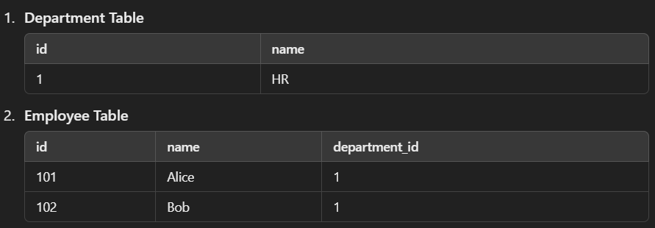

4. Many-to-Many (@ManyToMany)
- Multiple entities are related to multiple other entities.
- Requires a junction table to store the relationship.
- Used for students-courses, authors-books relationships.
import jakarta.persistence.*;
import java.util.List;

@Entity
public class Student {
@Id
@GeneratedValue(strategy = GenerationType.IDENTITY)
private Long id;

private String name;

@ManyToMany
@JoinTable(
name = "student_course",
joinColumns = @JoinColumn(name = "student_id"),
inverseJoinColumns = @JoinColumn(name = "course_id")
)
private List<Course> courses;
}

@Entity
public class Course {
@Id
@GeneratedValue(strategy = GenerationType.IDENTITY)
private Long id;

private String title;

@ManyToMany(mappedBy = "courses") // Inverse side
private List<Student> students;
}

Alternative: Unidirectional Many-to-Many
If Student owns the relationship and Course does not need to reference Student, you can remove mappedBy from Course:

@Entity
public class Student {
@ManyToMany
@JoinTable(
name = "student_course",
joinColumns = @JoinColumn(name = "student_id"),
inverseJoinColumns = @JoinColumn(name = "course_id")
)
private List<Course> courses;
}

Generated Tables:
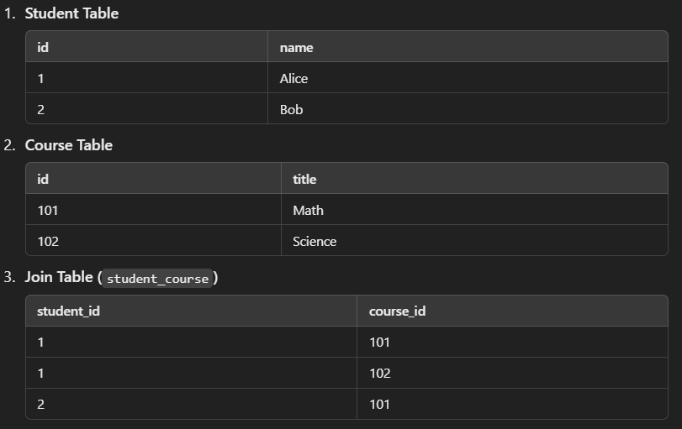

Key Points
• Owning Side: Student (declares @JoinTable)
• Inverse Side: Course (uses mappedBy = "courses")
• Cascade Options:
- CascadeType.ALL → Propagate all operations
- CascadeType.PERSIST → Save associated records automatically
- CascadeType.REMOVE → Delete associated records automatically
• Fetch Type:
- FetchType.LAZY (default) → Loads relationships on demand
- FetchType.EAGER → Loads relationships immediately

Example
🔹 Entity Class (JPA + Hibernate)
@Entity
@Table(name = "users")
public class User {
@Id
@GeneratedValue(strategy = GenerationType.IDENTITY)
private Long id;

@Column(nullable = false)
private String name;

@Column(unique = true, nullable = false)
private String email;
}
🔹 Spring Data JPA Repository
@Repository
public interface UserRepository extends JpaRepository<User, Long> {
User findByEmail(String email);
}
🔹 Service Layer
@Service
public class UserService {
@Autowired
private UserRepository userRepository;

public User createUser(User user) {
return userRepository.save(user);
}
}
Conclusion
  - JPA is a standard that defines how ORM should work in Java, while Hibernate is an implementation of JPA.
  - Hibernate provides additional performance enhancements like caching and custom query languages.
  - Spring Boot uses Spring Data JPA to simplify the integration of JPA and Hibernate.

Transactional
- The @Transactional annotation in Spring Boot manages database transactions automatically.
- It ensures that all database operations within a method are executed in a single transaction.
- If an exception occurs, the transaction is rolled back, preventing partial updates.

Transaction Propagation Types in Spring Boot
Spring supports different propagation types to control how transactions interact when calling multiple transactional methods.

1. REQUIRED (Default)
- If a transaction exists, the method joins the existing transaction.
- If no transaction exists, a new transaction is created.
- Example:
@Transactional(propagation = Propagation.REQUIRED)
public void methodA() {
methodB(); // Runs in the same transaction
}
✅ If methodA fails, both methodA and methodB are rolled back.

2. REQUIRES_NEW
- Always creates a new transaction, suspending any existing one.
- If an exception occurs in the new transaction, the parent transaction is not affected.
- Example:
@Transactional(propagation = Propagation.REQUIRES_NEW)
public void methodB() {
// Runs in a new transaction, independent of the caller
}
✅ If methodA calls methodB and methodB fails, methodA is not rolled back.

3. NESTED
- Executes within an existing transaction, but has its own savepoint.
- If methodB fails, only methodB is rolled back, but methodA continues.
- Example:
@Transactional(propagation = Propagation.NESTED)
public void methodB() {
// Creates a sub-transaction inside methodA's transaction
}
✅ Useful when only part of a transaction should be rolled back without affecting the whole.

4. SUPPORTS
- If a transaction exists, it runs inside the transaction.
- If no transaction exists, it runs non-transactionally.
- Example:
@Transactional(propagation = Propagation.SUPPORTS)
public void methodC() {
// Runs in a transaction if the caller has one
}
✅ Used for optional transactions where the method does not require a transaction but can use one if available.

5. NOT_SUPPORTED
- Runs outside of a transaction, suspending any existing transaction.
- Useful when a method should not participate in transactions (e.g., logging).
- Example:
@Transactional(propagation = Propagation.NOT_SUPPORTED)
public void methodD() {
// Executes without a transaction
}
✅ If methodD is called inside a transaction, it runs outside of it.

6. MANDATORY
- The method must be called inside an existing transaction.
- If no transaction exists, it throws an exception.
- Example:
@Transactional(propagation = Propagation.MANDATORY)
public void methodE() {
// Requires an active transaction; fails if none exists
}
❌ Throws an error if methodE is called without an active transaction.

7. NEVER
- The method must not be called within a transaction.
- If a transaction exists, it throws an exception.
- Example:
@Transactional(propagation = Propagation.NEVER)
public void methodF() {
// Fails if called inside a transaction
}
❌ If methodF is called within a transaction, it throws an error.

Choosing the Right Propagation Type
- ✅ Use REQUIRED (default) when you want methods to join the existing transaction.
- ✅ Use REQUIRES_NEW when you need a completely separate transaction.
- ✅ Use NESTED when a part of a transaction should be rollbackable independently.
- ✅ Use SUPPORTS for methods that can work with or without a transaction.
- ❌ Avoid MANDATORY, NEVER, and NOT_SUPPORTED unless explicitly required.

Transaction Isolation Levels in Spring Boot
Transaction isolation levels define how transactions interact with each other, especially concerning concurrent access to the database.

Supported Isolation Levels in Spring Boot (@Transactional)
Isolation Level | Dirty Reads | Non-Repeatable Reads | Phantom Reads
READ_UNCOMMITTED | ✅ Yes | ✅ Yes | ✅ Yes
READ_COMMITTED (Default in most DBs) | ❌ No | ✅ Yes | ✅ Yes
REPEATABLE_READ | ❌ No | ❌ No | ✅ Yes
SERIALIZABLE | ❌ No | ❌ No | ❌ No

1. READ_UNCOMMITTED (Lowest)
- Allows dirty reads (reading uncommitted changes from other transactions).
- Fast but unreliable.
@Transactional(isolation = Isolation.READ_UNCOMMITTED)
public void someMethod() { ... }
📌 Use Case: When performance is more important than accuracy.

2. READ_COMMITTED (Default in most DBs)
- No dirty reads (cannot read uncommitted changes).
- Allows non-repeatable reads (same query may return different results in the same transaction).
@Transactional(isolation = Isolation.READ_COMMITTED)
public void someMethod() { ... }
📌 Use Case: Standard level for most applications.

3. REPEATABLE_READ
- No dirty reads, no non-repeatable reads.
- Allows phantom reads (new rows added by another transaction may be visible).
@Transactional(isolation = Isolation.REPEATABLE_READ)
public void someMethod() { ... }
📌 Use Case: Prevents reading inconsistent data within a transaction.

4. SERIALIZABLE (Highest)
- No dirty reads, no non-repeatable reads, no phantom reads.
- Fully locks tables, highest consistency, but worst performance.
@Transactional(isolation = Isolation.SERIALIZABLE)
public void someMethod() { ... }
📌 Use Case: When absolute consistency is required (e.g., financial transactions).

Connection Pooling in Spring Boot
Connection pooling is a mechanism to reuse database connections instead of creating new ones for each request, improving performance and reducing resource consumption.

1. Default Connection Pool in Spring Boot
Spring Boot automatically uses HikariCP as the default connection pool when using Spring Data JPA or JDBC.
- Fastest and most optimized connection pool
- Low memory footprint
- Supports automatic leak detection

2. Configuring Connection Pooling in application.properties
# Database connection
spring.datasource.url=jdbc:mysql://localhost:3306/mydb
spring.datasource.username=root
spring.datasource.password=secret

# HikariCP settings
spring.datasource.hikari.maximum-pool-size=10
spring.datasource.hikari.minimum-idle=5
spring.datasource.hikari.idle-timeout=30000
spring.datasource.hikari.max-lifetime=1800000
spring.datasource.hikari.connection-timeout=30000

Key Parameters
Property | Description
maximum-pool-size | Max number of connections in the pool (default: 10)
minimum-idle | Min number of idle connections in the pool
idle-timeout | How long idle connections stay in the pool (in ms)
max-lifetime | Max lifetime of a connection before it's replaced
connection-timeout | Time to wait before timing out when a connection is unavailable

Aspect-Oriented Programming (AOP)
AOP is a programming approach that separates cross-cutting concerns like logging, security, and transaction management from the main business logic. Instead of adding these concerns inside every method, AOP allows applying them dynamically using aspects. Spring Boot provides built-in support for AOP using the Spring AOP module. We can modify both request and response using AOP by leveraging the @Around advice in Spring AOP. The ProceedingJoinPoint allows us to intercept, modify, and control the execution of a method.

Key Concepts in AOP
- Aspect – A class that contains cross-cutting logic.
- Advice – The action performed before, after, or around method execution.
- Join Point – A specific point in program execution where an advice can be applied.
- Pointcut – A condition that selects join points where an aspect should run.

Types of Advices in Spring AOP
- @Before Advice – Executes before the target method runs.
- @After Advice – Runs after the method completes (whether successful or not).
- @AfterReturning Advice – Runs after a method successfully returns a value.
- @AfterThrowing Advice – Runs if a method throws an exception.
- @Around Advice – Wraps around the target method, allowing control over execution.

Weaving
Weaving – The process of applying aspects to target methods. It is the process of linking aspects (cross-cutting concerns like logging, security, transactions) with the main application code.

Types of Weaving in AOP

Compile-Time Weaving
- Done at compilation using tools like AspectJ compiler (ajc).
- Aspects are merged with Java bytecode before execution.

Load-Time Weaving (LTW)
- Done when classes are loaded into the JVM.
- Uses Java agents or special class loaders.

Runtime Weaving (Spring AOP) (Most Common in Spring)
- Uses proxies (JDK Dynamic Proxy or CGLIB) to apply aspects at runtime.
- Works only with Spring Beans, not raw Java objects.

Exception Handling
Exception handling in Spring Boot ensures that applications can gracefully handle errors and provide meaningful responses to clients instead of raw stack traces.

1. Types of Exception Handling in Spring Boot
Spring Boot provides multiple ways to handle exceptions at different levels:
- Try-Catch Blocks – Handle exceptions within a method.
- @ExceptionHandler – Handle exceptions at the controller level.
- @ControllerAdvice – Global exception handling for multiple controllers.
- @ResponseStatus – Return specific HTTP status codes.
- Custom Exception Classes – Define business-specific exceptions.
- Spring Boot’s Default Error Handling (BasicErrorController) – Handles common errors automatically.

2. Handling Exceptions Using @ExceptionHandler (Controller Level)
Use @ExceptionHandler inside a controller to handle specific exceptions for that controller only.
import org.springframework.web.bind.annotation.*;

@RestController
@RequestMapping("/users")
public class UserController {

@GetMapping("/{id}")
public String getUser(@PathVariable int id) {
if (id <= 0) {
throw new IllegalArgumentException("Invalid User ID");
}
return "User Found";
}

@ExceptionHandler(IllegalArgumentException.class)
public String handleIllegalArgumentException(IllegalArgumentException e) {
return "Error: " + e.getMessage();
}
}
✅ If an invalid ID is provided, it returns a custom error message instead of a generic exception.

3. Handling Exceptions Using @ControllerAdvice (Global Exception Handling)
@ControllerAdvice allows handling exceptions globally for multiple controllers.
import org.springframework.web.bind.annotation.*;

@ControllerAdvice
public class GlobalExceptionHandler {

@ExceptionHandler(IllegalArgumentException.class)
@ResponseBody
public String handleIllegalArgument(IllegalArgumentException e) {
return "Global Error: " + e.getMessage();
}
}
✅ Now, any IllegalArgumentException thrown in any controller will be handled globally.

4. Handling Exceptions with @ResponseStatus
Use @ResponseStatus to return specific HTTP status codes for exceptions.
import org.springframework.http.HttpStatus;
import org.springframework.web.bind.annotation.*;

@ResponseStatus(HttpStatus.NOT_FOUND)
class UserNotFoundException extends RuntimeException {
public UserNotFoundException(String message) {
super(message);
}
}
Usage in Controller:
@GetMapping("/{id}")
public String getUser(@PathVariable int id) {
if (id <= 0) {
throw new UserNotFoundException("User not found");
}
return "User Found";
}
✅ Returns a 404 Not Found status when a user is not found.

5. Handling Exceptions with ResponseEntity (Custom Response)
Use ResponseEntity for full control over the response body and HTTP status code.
import org.springframework.http.ResponseEntity;
import org.springframework.web.bind.annotation.*;

@RestController
@RequestMapping("/users")
public class UserController {

@GetMapping("/{id}")
public ResponseEntity<String> getUser(@PathVariable int id) {
if (id <= 0) {
return ResponseEntity.badRequest().body("Invalid User ID");
}
return ResponseEntity.ok("User Found");
}
}
✅ This method returns a 400 Bad Request if the user ID is invalid.

6. Custom Exception Class and Global Handling
Define a custom exception and handle it globally.
Step 1: Create a Custom Exception
public class CustomException extends RuntimeException {
public CustomException(String message) {
super(message);
}
}
Step 2: Handle in Global Exception Handler
import org.springframework.http.HttpStatus;
import org.springframework.http.ResponseEntity;
import org.springframework.web.bind.annotation.*;

@ControllerAdvice
public class GlobalExceptionHandler {

@ExceptionHandler(CustomException.class)
public ResponseEntity<String> handleCustomException(CustomException e) {
return ResponseEntity.status(HttpStatus.BAD_REQUEST).body("Custom Error: " + e.getMessage());
}
}
Step 3: Throw the Custom Exception in Controller
@GetMapping("/{id}")
public String getUser(@PathVariable int id) {
if (id <= 0) {
throw new CustomException("Invalid User ID: " + id);
}
return "User Found";
}
✅ When an invalid ID is provided, it returns 400 Bad Request with a custom message.

7. Handling Validation Errors in Spring Boot
Spring Boot provides @Valid for validating request body data.
Example: Validating a Request DTO
import jakarta.validation.constraints.*;

public class UserDTO {
@NotBlank(message = "Name is required")
private String name;

@Email(message = "Invalid email format")
private String email;
}
Apply Validation in Controller
import org.springframework.validation.annotation.Validated;
import org.springframework.web.bind.annotation.*;

@RestController
@RequestMapping("/users")
public class UserController {

@PostMapping
public String createUser(@RequestBody @Validated UserDTO user) {
return "User Created: " + user.getName();
}
}
Handle Validation Errors in Global Exception Handler
import org.springframework.web.bind.MethodArgumentNotValidException;
import org.springframework.http.ResponseEntity;

@ControllerAdvice
public class GlobalExceptionHandler {

@ExceptionHandler(MethodArgumentNotValidException.class)
public ResponseEntity<String> handleValidationException(MethodArgumentNotValidException e) {
return ResponseEntity.badRequest().body("Validation Error: " + e.getBindingResult().getFieldError().getDefaultMessage());
}
}
✅ If an invalid request is sent, the validation error message is returned.

8. Spring Boot’s Default Exception Handling
Spring Boot has a built-in BasicErrorController that returns structured JSON error responses.
Example Response for a 404 Not Found Error:
{
"timestamp": "2024-02-03T12:00:00.000+00:00",
"status": 404,
"error": "Not Found",
"message": "No resource found",
"path": "/users/100"
}
✅ This is Spring Boot's default error response, which can be customized.

9. Customizing the Default Error Response
You can override Spring Boot’s default error handling by creating a custom error controller.
import org.springframework.http.HttpStatus;
import org.springframework.web.bind.annotation.*;

@RestController
@RequestMapping("/error")
public class CustomErrorController {

@GetMapping
@ResponseStatus(HttpStatus.BAD_REQUEST)
public String customError() {
return "Oops! Something went wrong.";
}
}
✅ This replaces Spring Boot's default error page with a custom response.

Spring Security
Spring Security provides authentication and authorization mechanisms to protect endpoints and enforce security policies. It supports role-based access control (RBAC), JWT authentication, OAuth2, OpenID Connect (OIDC), and external identity providers like Keycloak.
import org.springframework.context.annotation.Bean;
import org.springframework.security.config.annotation.web.builders.HttpSecurity;
import org.springframework.security.web.SecurityFilterChain;
import org.springframework.security.config.http.SessionCreationPolicy;

import static org.springframework.security.config.Customizer.withDefaults;

@Configuration
public class SecurityConfig {

@Bean
public SecurityFilterChain securityFilterChain(HttpSecurity http) throws Exception {
http
.csrf(csrf -> csrf.disable()) // Disable CSRF for API endpoints
.authorizeHttpRequests(auth -> auth
.requestMatchers("/public/**").permitAll() // Public endpoints
.requestMatchers("/admin/**").hasRole("ADMIN") // Admin endpoints
.requestMatchers("/user/**").hasRole("USER") // User endpoints
.anyRequest().authenticated() // Protect all other endpoints
)
.sessionManagement(sess -> sess.sessionCreationPolicy(SessionCreationPolicy.STATELESS)) // No sessions (for JWT)
.httpBasic(withDefaults()); // Basic authentication

return http.build();
}
}

What is CORS?
- CORS is a security feature in browsers that prevents requests from different origins unless explicitly allowed.
- If a frontend application (e.g., http://localhost:3000) tries to access an API hosted on a different origin (e.g., http://localhost:8080), the browser blocks the request unless CORS is enabled.

What is CSRF?
- CSRF (Cross-Site Request Forgery) is an attack where an attacker tricks a logged-in user into submitting a malicious request on their behalf.
- Example: If a user is logged into Bank.com and visits a malicious site, the attacker could make an unauthorized transfer request using the user’s session.
- CSRF protection is enabled by default in Spring Security.
- For REST APIs (stateless applications), CSRF should be disabled because APIs do not use traditional web sessions.

How to Prevent CSRF Attacks?
- Use CSRF Tokens.
- Generate a unique CSRF token and include it in every request.
- The server validates the token before processing the request.
- The token is unique for each user and session.
- Attackers cannot forge a valid CSRF token, so the request is rejected.

What is Session Management in Spring Security?
Spring Security manages user sessions for stateful applications. Different session policies can be applied based on security requirements.

1. STATELESS (For APIs & JWT Authentication)
- Spring Security does not create or use sessions.
- Every request must include authentication credentials (e.g., JWT token).
- Best for REST APIs.
http.sessionManagement(session -> session.sessionCreationPolicy(SessionCreationPolicy.STATELESS));

2. ALWAYS (Session Always Created)
- A session is always created, even if not needed.
- Best for traditional web applications where session tracking is necessary.

3. NEVER (No Automatic Session Creation)
- Spring never creates a session, but it will use an existing session if available.
- Useful when an app uses session management but doesn't enforce it.

4. IF_REQUIRED (Default Behavior)
- Session is created only when needed (e.g., during login).
- Best for applications with form-based authentication.

Bean Lifecycle

1. Bean Instantiation
- Spring creates an instance of the bean.
- Happens when the ApplicationContext starts.

2. Bean Initialization (Dependency Injection)
- Spring injects dependencies (via constructor, setters, or @Autowired).

3. Post-Initialization Hooks
- If a bean implements:
  - InitializingBean → Calls afterPropertiesSet()
  - @PostConstruct → Calls a method annotated with @PostConstruct
  - Custom init() method (if specified in @Bean(initMethod = "..."))

4. Bean is Ready for Use
- The bean is now fully initialized and ready to serve requests.

5. Pre-Destruction Hooks
- Before shutting down, Spring invokes destruction callbacks:
  - DisposableBean → Calls destroy()
  - @PreDestroy → Calls a method annotated with @PreDestroy
  - Custom destroy() method (if specified in @Bean(destroyMethod = "..."))

6. Bean is Destroyed
- Spring removes the bean from the context before shutting down.

Example: Implementing Bean Lifecycle Methods
import jakarta.annotation.PostConstruct;
import jakarta.annotation.PreDestroy;
import org.springframework.stereotype.Component;

@Component
public class MyBean {

public MyBean() {
System.out.println("1. Constructor: Bean is instantiated");
}

@PostConstruct
public void init() {
System.out.println("2. @PostConstruct: Bean is initialized");
}

@PreDestroy
public void destroy() {
System.out.println("3. @PreDestroy: Bean is about to be destroyed");
}
}

Using InitializingBean and DisposableBean

@Component
public class MyBean implements InitializingBean, DisposableBean {

@Override
public void afterPropertiesSet() {
System.out.println("Bean initialized (afterPropertiesSet)");
}

@Override
public void destroy() {
System.out.println("Bean destroyed (destroy)");
}
}

Using @Bean(initMethod, destroyMethod)

@Configuration
public class BeanConfig {

@Bean(initMethod = "customInit", destroyMethod = "customDestroy")
public MyBean myBean() {
return new MyBean();
}
}

class MyBean {
public void customInit() {
System.out.println("Custom init method");
}

public void customDestroy() {
System.out.println("Custom destroy method");
}
}

Rest Request Lifecycle Stages

Client Sends Request
  - A client (browser, Postman, mobile app) sends an HTTP request (GET, POST, PUT, DELETE).

Servlet Container (Tomcat) Receives the Request
  - The request first reaches Embedded Tomcat (or any configured servlet container).
  - Tomcat parses the request and hands it over to the DispatcherServlet.

DispatcherServlet Handles the Request
  - DispatcherServlet is the front controller in Spring MVC.
  - It delegates request processing to the appropriate components.

Handler Mapping Determines the Controller
  - Spring scans for a matching endpoint based on URL, HTTP method, and parameters.
  - It identifies the corresponding Controller method.

Controller Method is Invoked
  - The method defined in a @RestController is executed.

Service Layer (Business Logic Execution)
  - If the controller calls a @Service, it processes the request.

Repository Layer (Database Interaction)
  - If a database query is needed, the Service Layer calls a @Repository interface.

Data is Retrieved and Processed
  - The retrieved user is sent back up through Service → Controller.

Response is Serialized (Jackson/JSON Processing)
  - Spring Boot uses Jackson to convert the Java object into JSON.

DispatcherServlet Sends Response to Client
  - The serialized response is sent to the client as HTTP Response.

Client Receives Response
  - The client (browser, Postman, or mobile app) receives the response.

